1 Complete the rooms in a house.

- k _ _ _ _ _ _
- b _ _ _ _ _ _
- b _ _ _ _ _ _ _
- l _ _ _ _ _ r _ _ _
- d _ _ _ _ _ r _ _ _

2 Complete the furniture words.

- You sit on this. armchair
- You look at yourself in this. m_________
- You put books on these. s__________
- This is on the floor. c__________
- You cook food with this. c__________
- These are on windows. c__________
- You write at this. d_________
- You put clothes in this. w_________
- This is in the bathroom. t__________
- Light comes from this. l__________
- You wash in this. – s_________
- Sit on this to watch TV. – s_________

3 Find nine of the words in Exercise 1 in the word search.

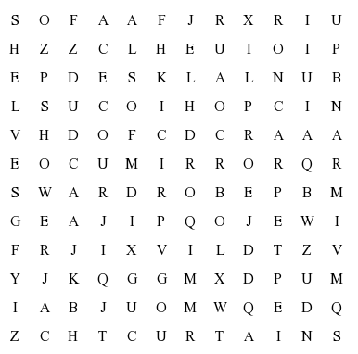

4 Complete the sentences with after, at, for, into or up. Use the verbs in brackets to help.

- Look at (= see) the boy playing in the street.
- I look _____ (= take care) my younger brother.
- Please look _____ (= check) this word in the dictionary.
- A: Where’s your phone?
B: I don’t know. I’m looking _____
(= search) it.
- The police are looking _____ (= investigate) why he stole the money.
- Can you look _____ (= find) the address on your phone?

5 Complete the sentences with the words in the list. There are three extra words.

bored I interested I annoyed I annoying I boring amazed I amazing I relaxed

- I haven’t got anything to do. I’m bored_.
- I love learning about music. It’s ________ .
- Stop touching my hair! It’s really ________!
- I feel very calm and ___________ today.
- She was _____________ by the paining. She thought it was fantastic.

6 Complete the dialogue with the words in the list. There are three extra words.

mean | could | honest | do | sure | about | why let’s | idea | hang | great
Kimberly: ¹Let’s go to the park for a picnic.
Jack: I don’t think that’s a good ²_____. It’s raining.
Kimberly: How ³_____ a picnic in the tent?
Jack: I’m not ⁴_____. The tent is very small.
Kimberly: OK. ⁵_____ don’t we have the picnic in the garage?
Jack: To be ⁶_____, that’s a bad idea. The garage is cold.
Kimberly: I know what you ⁷_____. Let’s go for a pizza then.
Jack: That’s a(n) ⁸_____ idea! I love pizzas.

